|  |  |  |
| --- | --- | --- |
|  | {Type the fire danger planning area title here} |  |
|  | **Preparedness Plan** |  |
|  | **{Enter the Month / Year here}** |  |

Contents

I. Introduction 1

A. Purpose 1

B. Preparedness versus Staffing Levels 1

1. Preparedness Levels 1

C. Policy and Guidance 1

II. Local Preparedness Level Worksheet – Example 1 3

A. Plinko Chart 3

III. Local Preparedness Level Worksheet – Example 2 4

A. Spreadsheet 4

B. Worksheet Guide Example 5

Appendix A 6

Recommended Actions Guide - *Example* 6

Agency Administrators 6

Fire Management Officers 6

Dispatch Center 7

Duty Officers 7

Prevention/Mitigation 7

Appendix B 9

Statistical Analyses 9

[Fire Danger Planning Area Title]

|  |  |  |  |
| --- | --- | --- | --- |
| **Preparedness Plan** | | | |
| **Approved By: *Agency Administrators*** | | | |
| **Insert agency logo and description.** |  |  |  |
|  | Name - Title  Agency Name, Office |  |  |
|  | | | |
| **Insert agency logo and description.** |  |  |  |
|  | Name - Title  Agency Name, Office |  |  |
|  | | | |
| **Insert agency logo and description.** |  |  |  |
|  | Name - Title  Agency Name, Office |  |  |
|  | | | |
| **Insert agency logo and description.** |  |  |  |
|  | Name - Title  Agency Name, Office |  |  |
|  | | | |
| **Insert agency logo and description.** |  |  |  |
|  | Name - Title  Agency Name, Office |  |  |
|  | | | |

This Page Intentionally Blank

|  |  |  |  |
| --- | --- | --- | --- |
| **[Fire Danger Planning Area Title]** | | | |
| **Preparedness Plan** | | | |
| **Recommended By: *Fire Program Managers*** | | | |
| **Insert agency logo and description.** |  |  |  |
| Name - Title  Agency Name, Office |  |  |
|  | | | |
| **Insert agency logo and description.** |  |  |  |
| Name - Title  Agency Name, Office |  |  |
|  | | | |
| **Insert agency logo and description.** |  |  |  |
| Name - Title  Agency Name, Office |  |  |
|  | | | |
| **Insert agency logo and description.** |  |  |  |
| Name - Title  Agency Name, Office |  |  |
|  | | | |
| **Insert agency logo and description.** |  |  |  |
| Name - Title  Agency Name, Office |  |  |
|  | | | |

This Page Intentionally Blank

|  |  |  |  |
| --- | --- | --- | --- |
| **[Fire Danger Planning Area Title]** | | | |
| **Preparedness Plan** | | | |
| **Prepared By: *Fire Danger* *Technical Group*** | | | |
| **Insert agency logo and description.** |  |  |  |
| Name - Title  Agency Name, Office |  |  |
|  | | | |
| **Insert agency logo and description.** |  |  |  |
| Name - Title  Agency Name, Office |  |  |
|  | | | |
| **Insert agency logo and description.** |  |  |  |
| Name - Title  Agency Name, Office |  |  |
|  | | | |
| **Insert agency logo and description.** |  |  |  |
| Name - Title  Agency Name, Office |  |  |
|  | | | |
| **Insert agency logo and description.** |  |  |  |
| Name - Title  Agency Name, Office |  |  |
|  | | | |

This Page Intentionally Blank

**Preparedness Plan**

# Introduction

## Purpose

Preparedness plans provide management direction given identified levels of burning conditions, fire activity, and resource commitment, and are required at national, state/regional, and local levels. Preparedness Levels (1-5) are determined by incremental measures of burning conditions, fire activity, and resource commitment. Fire danger rating is a critical measure of burning conditions. The Preparedness Levels are identified and documented in the [*Enter the name of your plan*] Fire Danger Operating Plan; the associated decisions and recommended actions are in Appendix A.

## Preparedness versus Staffing Levels

1. Preparedness Levels

Preparedness Levels often get confused with Staffing Levels. Staffing Levels only consider fire danger, while Preparedness Levels incorporate additional items, such as current level of local fire occurrence, live fuel moisture, and suppression resources committed. Additionally, Preparedness Levels incorporate stable variables (e.g. ERC, Live Fuel Moisture, 100-hr Fuel Moisture, etc.) to help with long-term decisions, such as the need to request severity funding or activation of public-use restrictions.

## Policy and Guidance

Policy and guidance regarding the development of Preparedness Level plans can be found in chapter 10 of the Interagency Standards for Fire & Aviation Operations (Red Book).

Preparedness Level Plans are required at the national, state/regional, and local levels. These plans address the five Preparedness Levels (1-5) and provide management direction based on identified levels of burning conditions (fire danger), fire activity, resource commitment/availability, such as incident management teams assigned, and other considerations (in contrast to Staffing Levels, which typically only consider fire danger). Preparedness Level Plans may be developed by a state/regional office for agency-specific use.

Supplemental preparedness actions to consider include, but are not limited to, the following items:

* Management briefings, direction, and considerations;
* Support function: consideration given to expanded dispatch activation and other support needs (procurement, supply, ground support, and communication);
* Support staff availability outside of fire organization;
* Fire danger/behavior assessment;
* Fire information – internal and external;
* Multi-agency coordination group/Area command activation; and
* Prescribed fire direction and considerations.

Refer to the National Interagency Mobilization Guide and GACC Mobilization Guides for more information on Preparedness Level Plans.

Specific agency directives and interagency guidance requires numerous unit plans and guides to meet fire preparedness and wildfire response objectives. Some of these plans and guides are inter-related; one or more plans/guides provide the basis for other plans/guides. The Preparedness Plan is an operational plan tiered from the Fire Danger Operating Plan as shown below:

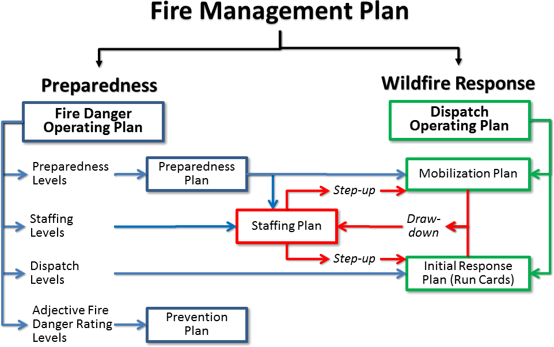

Preparedness Levels are established to assist fire managers with weekly or monthly planning decisions based upon seasonal fire danger elements. FireFamilyPlus is used to establish fire business thresholds. A statistical analysis of fire occurrence and historical weather needs to be completed for each FDRA. The correlation of various combinations of NFDRS outputs with weather records are listed in Appendix B. The final Preparedness Level determination may incorporate a measure of current and projected levels of resource commitment due to fire activity and a measure of ignition risk. Each agency will consider management actions identified in the FDOP appendix based upon the five local Preparedness Levels.

# Local Preparedness Level Worksheet – Example 1

## Plinko Chart

The preparedness level is a five-tier fire danger rating system that is based on NFDRS components (i.e. ERC, BI, Live Fuel Moisture, etc.) and indicators of fire business. Fire business indicators used to help determine the preparedness level may include the current level of fire activity in the zone, or the number of resources committed to suppression activities. ***It is up to each dispatch zone to develop a methodology or tool that works best for them to assist in determining the preparedness levels for their zone.*** This template provides two examples that display how preparedness levels may be decided.

The illustration below is an example of a “plinko chart” that uses a combination of ERC values for each FDRA, Live Fuel Moisture values from each FDRA, and the level of multiple large fire activity for each FDRA.

|  |  |  |  |  |  |  |  |  |  |  |  |  |  |  |  |  |  |  |  |  |  |  |  |  |  |  |  |  |  |  |  |  |  |  |  |  |  |  |  |  |  |
| --- | --- | --- | --- | --- | --- | --- | --- | --- | --- | --- | --- | --- | --- | --- | --- | --- | --- | --- | --- | --- | --- | --- | --- | --- | --- | --- | --- | --- | --- | --- | --- | --- | --- | --- | --- | --- | --- | --- | --- | --- | --- |
| **#1** | **ERC** |  | | | | | | | |  | | | | | | | |  | | | | | | | |  | | | | | | | |  | | | | | | | |
|  | **Model *XX* (FDRA 1)** | **0-55** | | | | | | | | **56-77** | | | | | | | | **78-86** | | | | | | | | **87-94** | | | | | | | | **95+** | | | | | | | |
|  | **Model *XX* (FDRA 2)** | **0-54** | | | | | | | | **55-68** | | | | | | | | **69-76** | | | | | | | | **77-83** | | | | | | | | **84+** | | | | | | | |
|  | **Model *XX* (FDRA 3)** | **0-31** | | | | | | | | **32-40** | | | | | | | | **41-48** | | | | | | | | **49-59** | | | | | | | | **60+** | | | | | | | |
|  | 🗹 **⇨** | 🞏 | | | | | | | | 🞏 | | | | | | | | 🞏 | | | | | | | | 🞏 | | | | | | | | 🞏 | | | | | | | |
|  |  |  | | | |  | | | |  | | | |  | | | |  | | | |  | | | |  | | | |  | | | |  | | | |  | | | |
| **#2** | **Live Fuel Moisture (%)** |  | |  | |  | |  | |  | |  | |  | |  | |  | |  | |  | |  | |  | |  | |  | |  | |  | |  | |  | |  | |
|  | **Model *XX* (FDRA 1)** | **100+** | | | | **<100** | | | | **100+** | | | | **<100** | | | | **100+** | | | | **<100** | | | | **100+** | | | | **<100** | | | | **100+** | | | | **<100** | | | |
| **Model *XX* (FDRA 2)** | **100+** | | | | **<100** | | | | **100+** | | | | **<100** | | | | **100+** | | | | **<100** | | | | **100+** | | | | **<100** | | | | **100+** | | | | **<100** | | | |
| **Model *XX* (FDRA 3)** | **100+** | | | | **<100** | | | | **100+** | | | | **<100** | | | | **100+** | | | | **<100** | | | | **100+** | | | | **<100** | | | | **100+** | | | | **<100** | | | |
|  | 🗹 **⇨** | 🞏 | | | | 🞏 | | | | | | | | 🞏 | | | | | | | | 🞏 | | | | | | | | 🞏 | | | | | | | | 🞏 | | | |
|  |  |  | |  | |  | |  | |  | |  | |  | |  | |  | |  | |  | |  | |  | |  | |  | |  | |  | |  | |  |  |  |  |
| **#3** | **Multiple Large Fire Activity** |  |  |  |  |  |  |  |  |  |  |  |  |  |  |  |  |  |  |  |  |  |  |  |  |  |  |  |  |  |  |  |  |  |  |  |  |  |  |  |  |
|  | **2 or more ICS-209’s** |  |  |  |  | **No** | | | | **Yes** | | | | **No** | | | | **Yes** | | | | **No** | | | | **Yes** | | | | **No** | | | | **Yes** | | | |  |  |  |  |
|  | 🗹 **⇨** |  |  | 🞏 | | | | |  |  | 🞏 | | | | | |  |  | 🞏 | | | | | |  |  | 🞏 | | | | | |  |  | 🞏 | | | | |  |  |
|  |  |  |  |  |  |  |  |  |  |  |  |  |  |  |  |  |  |  |  |  |  |  |  |  |  |  |  |  |  |  |  |  |  |  |  |  |  |  |  |  |  |
|  | **Preparedness Level** | **I** | | | | | | | | **II** | | | | | | | | **III** | | | | | | | | **IV** | | | | | | | | **V** | | | | | | | |

# Local Preparedness Level Worksheet – Example 2

## Spreadsheet

The example below uses a spreadsheet to assist in determining the preparedness level for the dispatch zone. This example incorporates the use of a 5-day ERC average, the level of resource commitment in the zone, zone-wide fire activity, the geographic area preparedness level, and the 7-day fire potential for the zone, provided by the geographic area predictive services group. A worksheet was also developed to help guide personnel through the process (see Worksheet Guide Example).

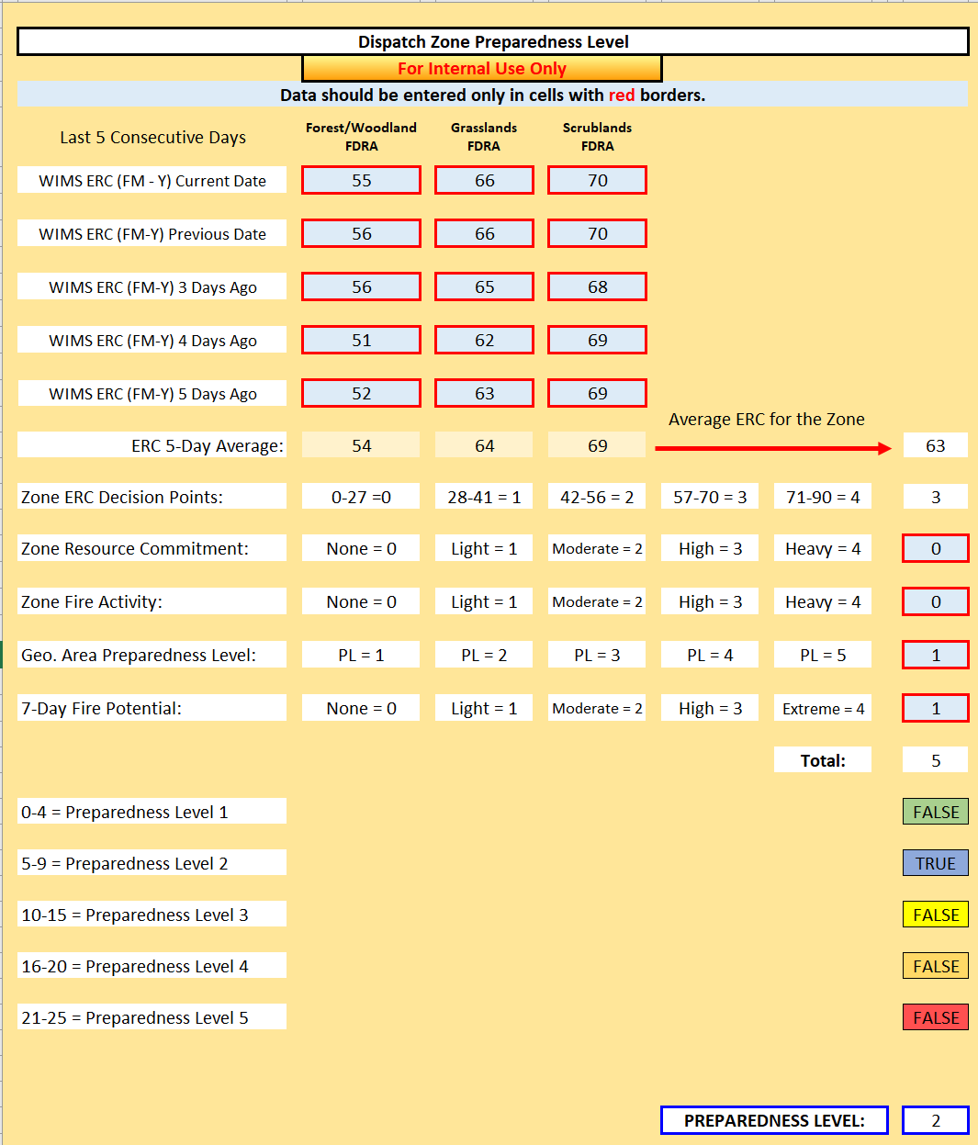

## Worksheet Guide Example

* **5 Consecutive Day ERC** – Values acquired from WIMS are averaged into one ERC value based on the selected RAWS Stations.
* **Zone ERC Decision Points** – Created in FireFamilyPlus. This value is automatically calculated in the table.
* **Resource Commitments**

Enter the appropriate “Resource Commitment” value for the Dispatch Zone based on the following criteria:

* + Utilize ROSS and WildCAD to determine total number of resources.
  + **0 - None** = No Resources Committed
  + **1 - Low** = Low/Occasional resource commitment
  + **2 - Moderate** = Approximately 50% of the resources are committed
  + **3 - High** = Approximately 75% of the resources are committed
  + **4 - Heavy** = Most resources are committed, and out-of-Zone assistance is needed.
* Fire Activity – Within the Dispatch Zone

Enter the appropriate “Fire Activity” value for the Southeast Zone based on the following criteria:

* + **0 - None** = No fire activity
  + **1 - Light** = Fire occurrence usually contained in 1 burning period and is successfully managed with local resources
  + **2 - Moderate** = Daily initial attack in some areas and with incidents burning more than 1 burning period and out-of-Zone resources are needed to assist.
  + **3 - High** = Most FDRAs are experiencing new incidents daily and extended attack fires are common. Resource needs may require out-of-Zone assistance.
  + **4 - Heavy** = New incident Initial Attack capability is compromised due to ongoing multi-fire activities and lack of resources. Resource requests from outside the Zone are common.
* **Geographic Area Preparedness Level** – Reported by the GA Coordination Center
* **7-Day Outlook/Fire Potential Trend (GA Predictive Services)**

Use the 7-Day Fire Potential Outlook information located on the GA Coordination Center website. Enter the appropriate value based on the following criteria:

* **0 - None** = All forecast days are displayed in green/yellow with no increase in potential within 7 days
* **1 - Low** = No more than 25% (2 days) of all forecast days are displayed in brown, no high-risk event within the 7-day forecast period.
* **2 - Moderate** = No more than 50% (3-4 days) of all forecast days are displayed in brown, no high-risk event within the 7-day forecast period.
* **3 - High** = No more than 75% (5 days) of all forecast days are displayed in brown, no high-risk event within the 7-day forecast period.
* **4 - Extreme** = All forecast days are *consistently* displayed in brown, several high-risk occurrence events (hot, dry, unstable [H], windy, dry, unstable [W], lightning, LAL >3 [L]) within the 7-day forecast period.

# Appendix A

## Recommended Actions Guide - *Example*

Preparedness Level (PL) Actions are guides for agency personnel to refer to when preparedness level thresholds are reached. If an agency doesn’t have a specific position that is listed within the PL table, that agency will utilize discretion as to what position will assume those roles (see examples below). Refer to the GACC and local unit Mobilization Guides for more information on Preparedness Level Plans.

## Agency Administrators

|  |  |  |  |  |  |  |  |
| --- | --- | --- | --- | --- | --- | --- | --- |
| **Responsible Party** | **Suggested Action** | **PL 1** | **PL 2** | **PL 3** | **PL 4** | **PL 5** | **Affected Entity** |
| **Agency Administrator** | Ensure Resource Advisors (READ) are designated and available for fire assignments. |  |  |  | **X** | **X** | Agency |
| Evaluate work/rest needs of fire staff. |  |  |  | **X** | **X** | Agency |
| Provide appropriate support to fire staffs regarding the implementation of preparedness level actions (i.e. severity requests, restrictions and closure planning). |  |  |  | **X** | **X** | Agency |
| Issue guidance to staff indicating severity of the season and increased need and availability for fire support personnel (i.e. availability for large fire support). |  |  |  | **X** | **X** | Agency |
|  |  |  |  |  |  |  |
|  |  |  |  |  |  |  |

## Fire Management Officers

|  |  |  |  |  |  |  |  |
| --- | --- | --- | --- | --- | --- | --- | --- |
| **Responsible Party** | **Suggested Action** | **PL 1** | **PL 2** | **PL 3** | **PL 4** | **PL 5** | **Affected Entity** |
| **USFS Fire Staff, BLM District FMO, NPS FMO, USFWS FMO,**  **State District FMO, BIA FMO** | Evaluate season severity data (NFDRS indices for the season, fuel loading, fuel moisture, drought indices, long-term forecasts). |  | **X** | **X** | **X** | **X** | Agency |
| Brief agency administrator on burning conditions and fire activity. |  |  | **X** | **X** | **X** | Agency |
| Review geographical and national preparedness levels and evaluate need to suspend local Rx fire activities. |  |  | **X** | **X** | **X** | Agency |
| Consider consulting with or ordering an FBAN or WFDSS Support. |  |  | **X** | **X** | **X** | Agency |
| Ensure Prevention Officer has initiated media contacts and public education contacts. |  |  | **X** | **X** | **X** | Agency |
| Ensure agency staff personnel are briefed on increasing fire activity. |  |  |  | **X** | **X** | Public Industry |
| Consider fire severity request and pre-positioning of resources including: suppression resources, aerial support, aerial supervision, command positions, dispatch, logistical support, and prevention. |  |  |  | **X** | **X** | Agency |
| If preparedness level is decreasing, consult with Duty Officer/Dispatch Center Manager and consider release of pre-positioned or detailed personnel. |  |  |  | **X** | **X** | Agency  Public Industry |
| Evaluate crew and staff work/rest requirements. |  |  |  | **X** | **X** | Agency |
| Coordinate with interagency partners the need for fire restrictions or closures. |  |  |  | **X** | **X** | Agency |
| Communicate with Dispatch Center Manager on geographical conditions and resources availability. |  |  |  | **X** | **X** | Public Industry |
| Request the agency administrator to issue guidance to agency staff regarding the need for increased availability in support positions. |  |  |  | **X** | **X** | Agency |
|  |  |  |  |  |  |  |

## Dispatch Center

|  |  |  |  |  |  |  |  |
| --- | --- | --- | --- | --- | --- | --- | --- |
| **Responsible Party** | **Suggested Action** | **PL 1** | **PL 2** | **PL 3** | **PL 4** | **PL 5** | **Affected Entity** |
| **Dispatch Center** | If preparedness level is decreasing, consider release of pre-positioned or detailed dispatchers and logistical support personnel. |  | **X** | **X** | **X** |  | Agency |
| Begin weekly conference calls with Zone FMOs and Operations staff. |  |  |  | **X** | **X** | Agency |
| Consider pre-positioning or detail of off-unit IA dispatchers and logistical support personnel. |  |  | **X** | **X** | **X** | Agency |
| Evaluate work/rest needs of center staff. |  |  |  | **X** | **X** | Agency |

## Duty Officers

|  |  |  |  |  |  |  |  |
| --- | --- | --- | --- | --- | --- | --- | --- |
| **Responsible Party** | **Suggested Action** | **PL 1** | **PL 2** | **PL 3** | **PL 4** | **PL 5** | **Affected Entity** |
| **Duty Officer\*** | If preparedness level is decreasing, consider releasing pre-positioned and detailed resources. |  | **X** | **X** | **X** |  | Agency |
| Ensure incoming pre-position or detailed personnel are briefed on local conditions. |  |  | **X** | **X** | **X** | Agency |
| Evaluate work/rest needs of IA crews, dispatchers and aviation bases. |  |  | **X** | **X** | **X** | Agency |
| Consider patrols and pre-positioning of local IA resources in high risk areas. |  |  |  | **X** | **X** | Agency |
| Consider pre-positioning and/or detailing of additional IA resources from off-unit. |  |  |  | **X** | **X** | Agency |
| Consider bringing in local resources from scheduled days off. |  |  |  | **X** | **X** | Agency |
|  |  |  |  |  |  |  |

## Prevention/Mitigation

|  |  |  |  |  |  |  |  |
| --- | --- | --- | --- | --- | --- | --- | --- |
| **Responsible Party** | **Suggested Action** | **PL 1** | **PL 2** | **PL 3** | **PL 4** | **PL 5** | **Affected Entity** |
| **Fire Prevention/**  **Mitigation** | Contact Public Information Officer, local media to inform of the start of fire season and the potential for local fire danger to increase. |  |  | **X** | **X** | **X** | Agency  Public |
| Provide public and industry with access to fire danger information, closures, restrictions and warnings. |  |  | **X** | **X** | **X** | Agency  Public  Industry |
| Post signs and warnings in camping and recreation areas. |  |  | **X** | **X** | **X** | Public |
| Consider need for increased fire prevention patrols. |  |  |  | **X** | **X** | Agency |
| Notify local media if High/Extreme fire danger and the need for increased public caution. |  |  |  | **X** | **X** | Public |
| Contact local fire chiefs and inform of increased fire danger. |  |  |  | **X** | **X** | Agency |
| Consult with FMO regarding need for fire restrictions or closures. |  |  |  | **X** | **X** | Agency |

# Appendix B

## Statistical Analyses