User Guide for FEMS Dispatch Auto Climatology 5 Stations Spreadsheet
The intent of this spreadsheet is to provide users one method to ingest FEMS data and produce the NFDRS output values and percentiles for a single station or averaged outputs for multiple stations. It will also provide staffing levels, dispatch levels and adjective rating from the old WIMS calculations. Those calculations are not a national standard and are for reference purposes only. Field units and dispatch centers should utilize breakpoints if they have completed a fires analysis for the local area. The outputs on the spreadsheet are based solely on climatological data. The spreadsheet is not a national standard document and users are encouraged to develop their own products as needed. Averaging multiple stations together should be done with caution since it is likely to reduce the overall understanding of fire danger values that individual stations provide, and it is encouraged to monitor all stations of interest individually.
The spreadsheet is locked except for the yellow highlighted cells and the green highlighted Station ID cells.
This spreadsheet is set up to automatically pull all climatological data from FEMS once the station ID’s are populated. Each tab in the spreadsheet is set up to handle that number of stations. FDRA 1 station is only used for 1 station. FDRA 2 station allows for 2 stations. Do not modify the number of stations on each tab as it will break the spreadsheet.
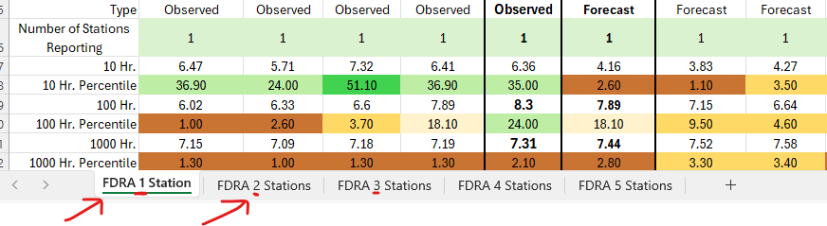
Step 1. When the spreadsheet is opened for the first time on your machine Excel may ask about privacy levels. Choose Ignore Privacy levels for this file. From the drop down, click on https://fems.fs2c.usda.gov/. Click OK.
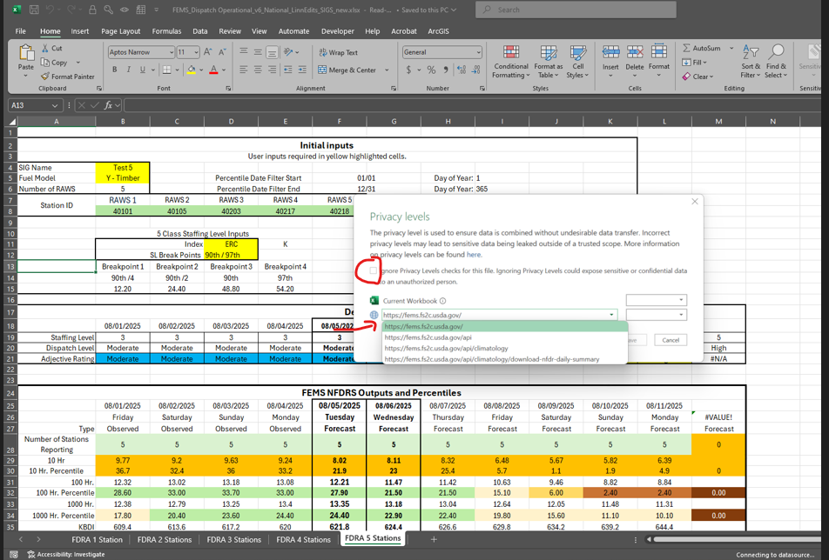
Step 2. Rename the file for your specific use. Click on File and choose Save As. Then at the bottom of the excel document, rename FDRA 1 Station to one of the FDRA’s in your area that you want to monitor. Right click on the FDRA 1 Station tab and choose Rename. Repeat this for each FDRA 2-5 as needed.
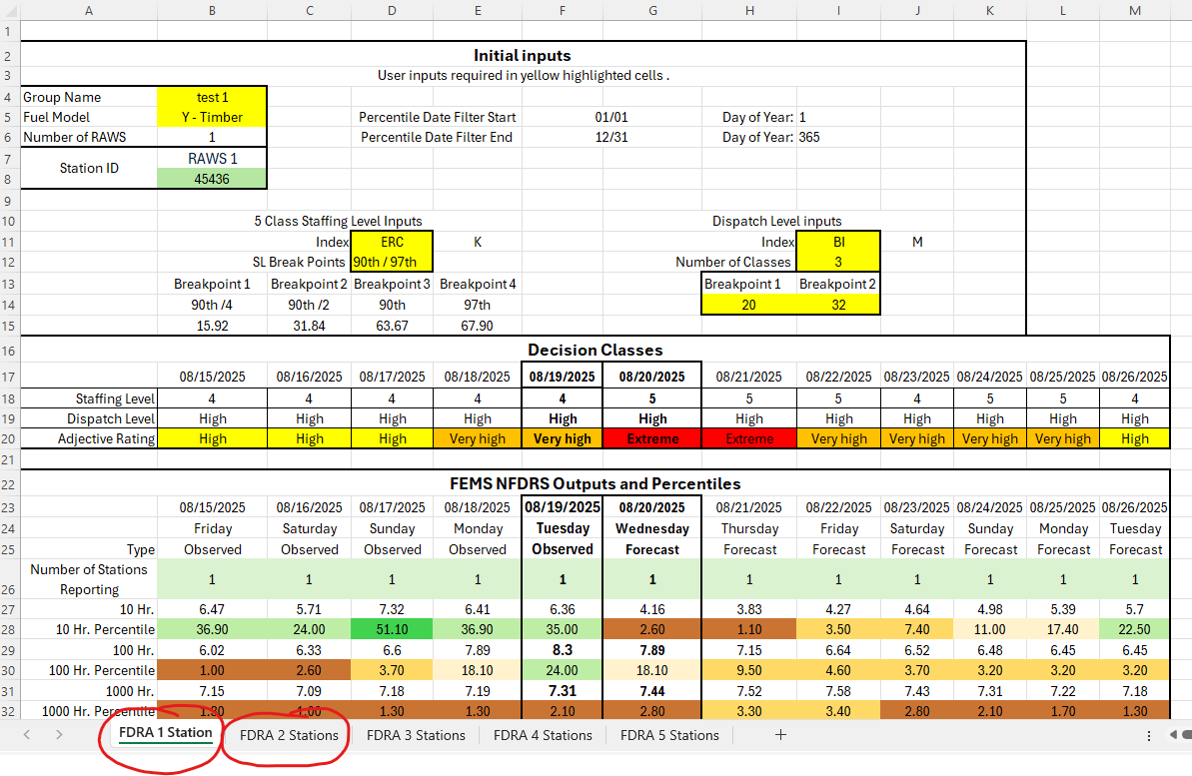
Step 3. Enter the name of your area in the Group name. Choose the Fuel Model from the drop-down list and enter the number of weather stations in that FDRA. This is completed in the yellow highlighted cells.
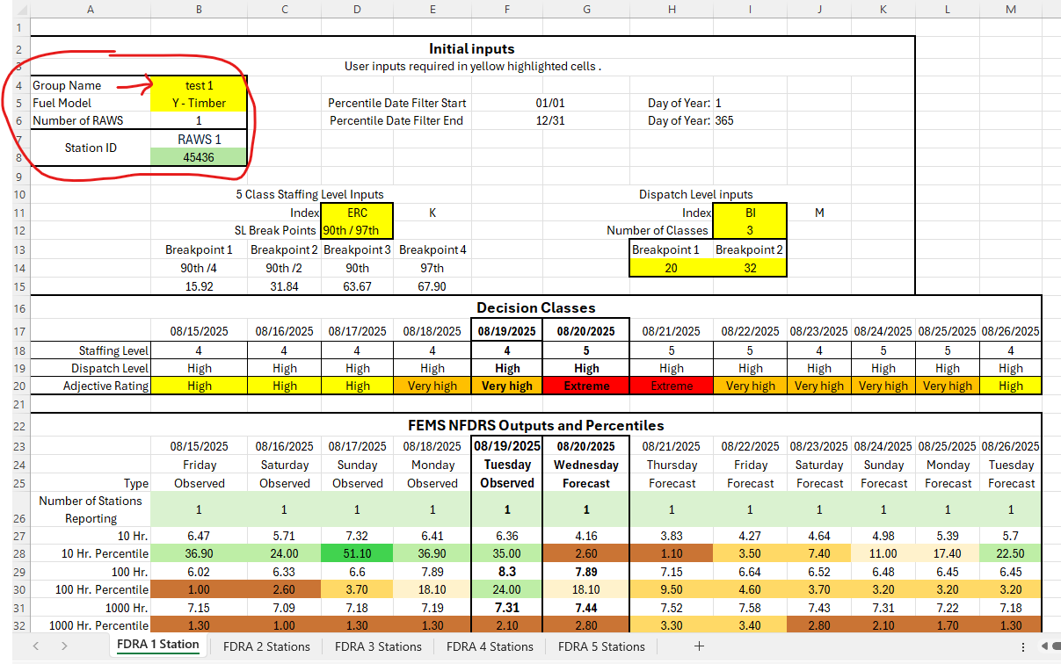
Step 4. Enter the station ID number in the green highlighted cells.
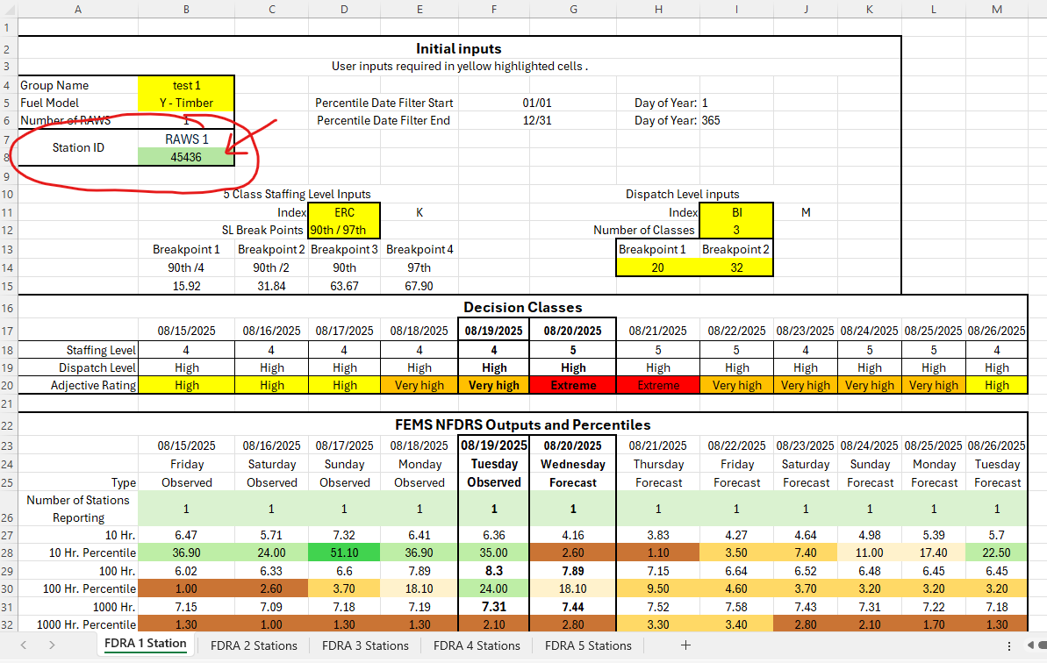

Step 5. Choose the staffing level inputs index and breakpoints in the drop-down menu. No options for customized breakpoints exist.
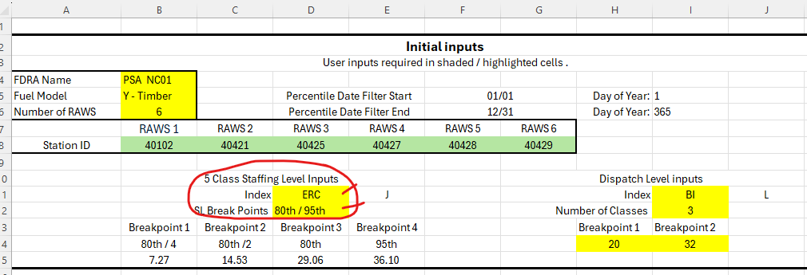
Step 6. OPTIONAL: If you have completed an analysis with FEMS data for Dispatch levels enter the Index, number of classes and the breakpoints in the Dispatch Levels Inputs.
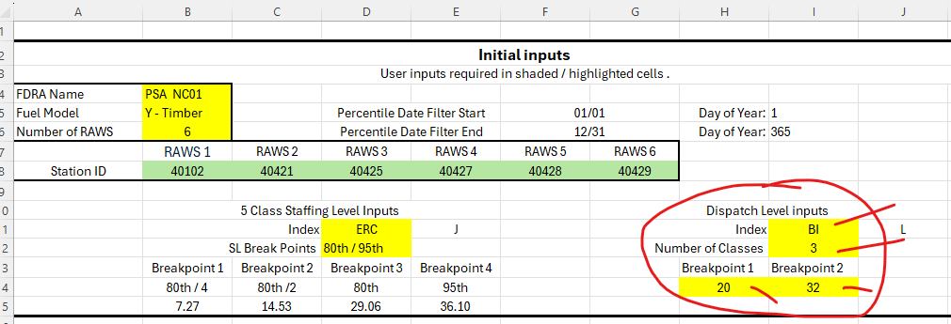
Step 8. On the top of the excel file, go to Data tab and click refresh all. Be patient as the data loads from FEMS.
